Ideal finite element

 

1. Ellipticity (Positive strain energy)

FE should have only 6 zero energy mode corresponding to 6 rigid body motion



Extra zero energy mode 🡪 spurious zero energy mode

2. Consistency: FE is based on mathematical model. As h decrease, the solution of FE model should converge that of the corresponding mathematical model



3. Uniform optimal convergence

🡪 No locking

🡪 Convergence should not depend on material or geometrical property.

Locking: the term “locking” refers to excessive stiffness in one or more deformation modes

1. Volumetric locking (2d-3d plane, solid elements):

Convergence depends on poison ratio, , error increases

, , 

If , very small change strain🡪 big change in pressure(sensitive)

**A pathological case of volume locking in triangular elements**

Consider triangle 1, in Figure 1, which is defìned by nodes 1 and 2 on the x axis, and node 3 on the y axis. The area of the triangle is (x2 - x2)y3/2, and it must remain constant if the triangle is incompressible. If nodes 1 and 2 are ixed, then y3 must remain constant and v3 = 0. The remaining degree of freedom is the horizontal displacement u3. Similarly, for the triangle 2, deined by nodes 4, 5, and 6, the only remaining degree of freedom is the vertical displacement v6.

*Two triangles may be assembled into a quadrilateral region, see Figure 2. Since incompressibility for triangle 1 requires v4 = 0 and incompressibility for triangle 2 requires u4 = 0, node 4 cannot move, and the elements are completely locked up.* With nodes 1 through 4 locked up, the nodes for triangles 3 and 4 will also be locked, as will the ones for triangles 5 and 6, see Figure 3. Again, since all previous triangles are locked, adding triangles

1. 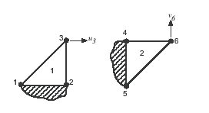

Figure 1: The remaining degrees of freedom for two incompressible constant strain triangles.

1. 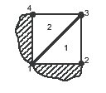

Figure 2: Two incompressible constant strain triangles assembled into a quadrilateral lock.

... 7 and 8 will result in their nodes also being locked. Elements can continue to be added in the same pattern, and all the nodes will be locked. Analogous problems occur in three dimensions with tetrahedral elements.

2. Shear locking (beam, plate, shell, 2d/3d solid): happens in bending problem

Wrong behavior shear strain: as , transverse shear strain overestimate in pure bending

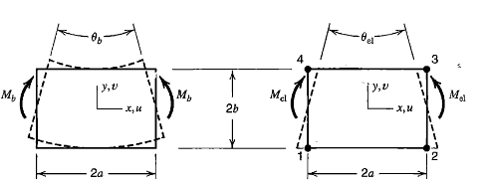

In Q4 elements, element strains are

, , 

In the case of pure bending a block of material has strains

, , 

Ratio of rotation produced is



 approaches zero as aspect ratio increase without limit

3. Membrane locking (Curved beam, shell element): in bending problem

As , membrane strain overestimate in pure bending

Constraint counting

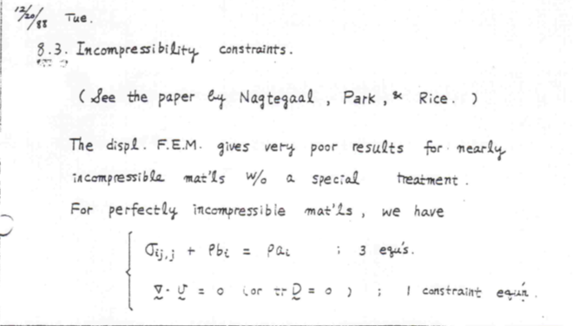

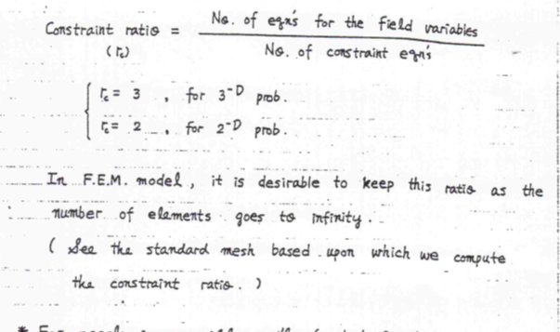

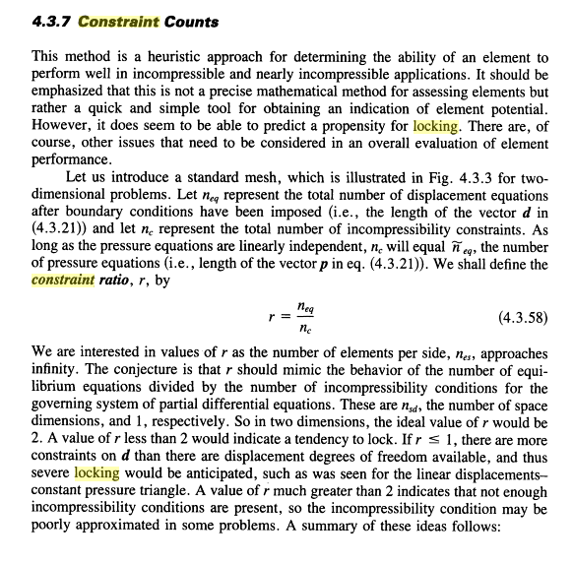 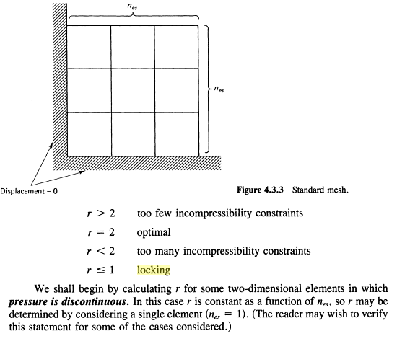

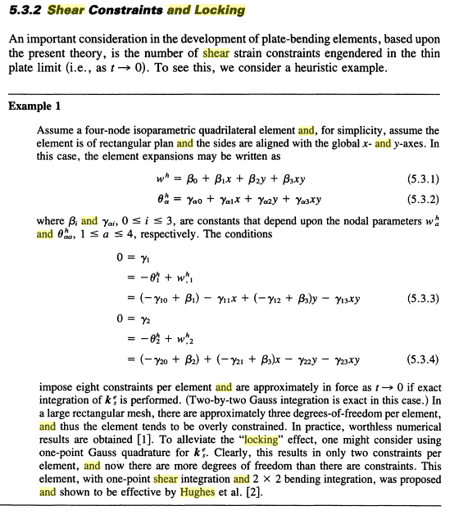 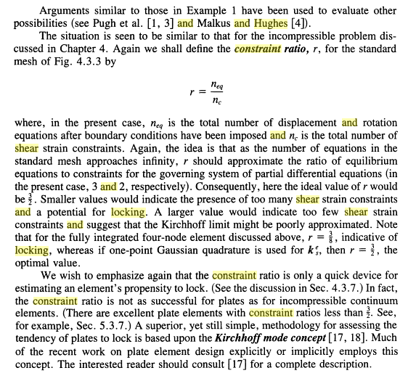

**3.10 Improved triangles and quadrilaterals**

3절점 삼각형 요소나 4절점 사각형요소의 성능을 향상 시키는 방법으로는 drilling dof를 도입하는 방법이 있다. 또한 4절점 요소의 경우, 추가적인 비적합 모드(incompatible modes) 과 under integration을 이용하는 방법이 있다.

3.10.1 drilling dof: drilling dof는 평면요소에서 각각의 자유도에 회전 자유도를 부여한 형태이다. 이 요소의 목적은 각 vertex에 절점을 추가시킨 요소보다 더 작은 자유도를 가진 상태에서, 기존의 요소의 단점인 parasitic shear현상을 줄이는데 있다.

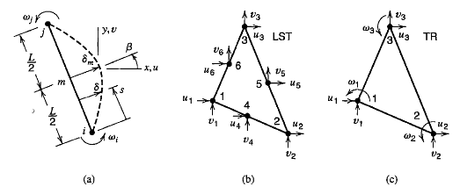

Drilling dof 와 LST 요소와는 다음과 같은 관계식이 성립한다.





3.10.2 Incompatible modes (Q6 element): Q4 요소가 locking 에 걸리는 이유가 2차 항이 없음을 상기 할 때, Q6 요소는 Q4 요소에 추가적인 모드를 부여함으로써 아래와 같이 구성된다.

, 

, 

Q6 요소는 비적합 (incompatible)이며, 요소 사이에 gap 이 발생할 수 있다. 하지만 요소가 refined 됨에 따라 정해로의 수렴이 가능하다.

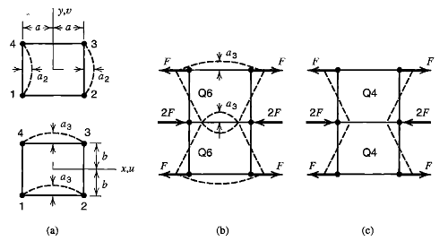

3.10.3 Underintergration: 수치적분을 one-point quadrature을 통하여 수행할 수 있다.